



**PHYSICS INVESTIGATORY PROJECT**

Topic: **“*Logic Gates”***

|  |  |  |
| --- | --- | --- |
| **Submitted by:-** | | **Submitted to:-** |
| **Name** | **:KARAN SHARMA** | **Mr. YASHPAL SINGH** |
| **Class** | **:XII – B** | *(PGT- Physics)* |
| **Board Roll No.** | **:** | Department of Physics |
| **Session** | **:2019-20** | St. Anselm’s Pink City Sr. Sec. School, Malviya Nagar, Jaipur - 302017 |

,

**Certificate**

This is to certify that the “*Physics Investigatory Project*” made by **Karan Sharma** of **Class XII – B** on the topic “**Logic Gates**” has been successfully completed under my supervision in fulfillment of the curriculum of Central Board of Secondary Education [CBSE].

**(Mr. YASHPAL SINGH)**

(PGT-Physics)

(St. Anselm’s Pink City Sr. Sec School)

**ACKNOWLEDGEMENT**

I am very much grateful to our school for giving me the chance to carry out my *“Physics Investigatory Project”* at its premises for the session 2019-20.

I would like to express my deepest sense of gratitude to Mr. Yashpal Singh Sir, our Physics Teacher at St. Anselm’s Pink City Sr. Sec School for his constant inspiration, valuable suggestions and constructive criticism at every stage of my work.

**(Karan Sharma)**

**Class: XII – B**

# INDEX

|  |  |
| --- | --- |
| **S. No.** | **Topic** |
| 1. | Acknowledgement |
| 2. | Certificate |
| 3. | Introduction |
| 4. | Basic Terminology |
| 5. | Basic Gates |
| 6. | AND Gate |
| 7. | Digital Circuit Consisting AND Gate |
| 8. | Working of AND Gate |
| 9. | Bibliography |

# INTRODUCTION

A gate is defined as a digital circuit which follows some logical relationship between the input and output voltages. It is a digital circuit which either allows a signal to pass through or stop it. The logic gates are building blocks at digital electronics. They are used in digital electronics to change one voltage level into another according to some logic statement relating to them. These gates allow signals to pass through them only when some logic is satisfied.

These gates are related to Boolean algebra.

Boolean algebra: - The algebra which is based on binary nature of the logic gates.

Boolean Expressions: - They are the logical statement which are followed by logical gates

Principle Any Boolean algebraic operation can be associated with the input and output, which represents the statement of Boolean algebra. Although these circuits may be complex, they may all be constructed from three basic Devices like a P-N junction diode, a resistance and an N-P- N transistor

A semiconductor diode (P‐N junction) acts as a closed switch when it is forward biased, i.e. it allows current to pass through it. It acts as an open circuit when it is reversed biased, i.e. it allows very little or no current to pass through it. This unique property of diode is employed in the design of logic gates and the circuits

Truth Table: - A logic gate may have one or more than one inputs, but it has only one output. The relationship between the possible values of input and output voltages are expressed in the form of a table called truth table. Truth table of a logic gate is a table that shows all the inputs and outputs that are possible for the logic gates.

.

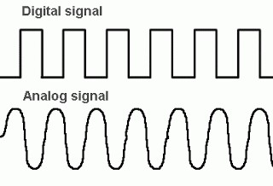

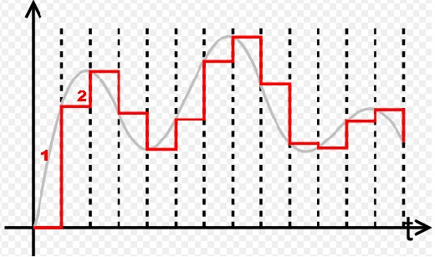

# BASIC TERMINOLOGY

## Signal

Information converted in electrical form and suitable for transmission is called a signal. There are two types of signals:‐  i) Analog signal ii) Digital signal

## •Analog signal

Analog signals are continuous variation of voltage or current. They are essentially single‐valued function of time. Sine wave is fundamental analog signal.

## •Digital signal

Digital signal are those which can take only discrete step wise values. Binary system that is extensively used in digital electronics employs just two levels of a signal. ‘O’ corresponds to low level and ‘1’ corresponds to high level of voltage or current.

## •Digital circuit

The electrical circuit which uses only digital signals is called digital circuit.

•**Logic Gate**

A digital circuit which allows a signal to pass through it or stops is called a gate.

When such gate allows the signal to pass through only when some logical condition is satisfied, they are called logic gates. Each logic gate follows certain logical relationship between input and output voltage. It is used in calculators, etc.

# BASIC GATES

There are three basic logic gates. They are combined together to form several other logic gate. These logic gates are the building block of digital circuit.

The basic logic gates are:‐

1. OR GATE
2. AND GATE
3. NOT GATE

The logic gates are represented with specific symbols in digital circuit.

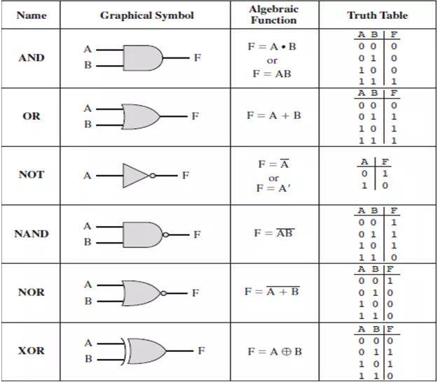

## •Truth Table

It is a table that shows all possible input combinations and the corresponding output combination for a logic gate.

## OR GATE

It is a device that combines A and B to give Y as the result. The OR gate has two or more inputs and one output. In Boolean algebra, addition symbol (+), is referred as the OR.

The Boolean expression: A+B=Y. This indicates that Y equals to A or B.

The symbolic diagram of ‘OR GATE’ with two inputs and the truth table is shown:

**The OR Gate Aim:**

To design and stimulate the OR gate circuit. Components: Two ideal p-n junction diode (D1 and D2). Theory and Construction: An OR gate can be realized by the electronic circuit, making use of two diodes D1 and D2. Hear the negative terminal of the battery is grounded and corresponds to the 0 level, and the positive terminal of the battery corresponds to level 1. The output Y is voltage at C with respect to earth.

The following conclusion can be drawn from the above circuit:

(i) If the switch A and B are kept open (A=1, B=0), then bulb does not glow, hence Y=0

(ii) If switch A is kept closed and B is kept open (A=1, B=0), then bulb does not glow, hence Y=0

(iii) If switch A is kept open and B is kept closed (A=0, B=1), then bulb does not glow, hence Y=0

(iv) If switch A and B both are kept closed (A=1, B=1), then bulb glows, hence Y=1

TRUTH TABLE: Input A Input B OUTPUT 0 0 0 0 1 0 1 0 0 1 1 1

## NOT GATE

It is a device that inverts the inputs. The NOT has one input and has one output. In Boolean algebra, bar symbol is referred as the NOT.

The Boolean expression: This indicates that Y is not equal to A.

The symbolic diagram of ‘NOT GATE’ with one input and the truth table is shown:

# AND GATE

It is a device that combines A with B to give Y as the result. The AND gate has two or more inputs and one output. In Boolean algebra, multiplication sign is referred as the AND. The gate only gives output when both the switches A and B are closed.

The Boolean expression: A.B=Y or A X B=Y. This indicates that Y equals to A and B.

The symbolic diagram of ‘AND GATE’ with two inputs and the truth table is shown:

The simplified AND gate as shown has two inputs, switch A and B. The bulb Q will only light if both switches are closed. This will allow current to flow through the bulb, illuminating the filament.

**The AND Gate Aim:**

TO DESIGN AND STIMULATE THE AND GATE CIRCUIT.

***Components***: Two ideal p-n junction diode (D1 and D2) and resistance R. ***Theory and Construction:*** An AND gate can be realized by the electronic circuit, making use of two diodes D1 and D2. The resistance R is connected to the positive terminal of a 5V battery permanently. Here the negative terminal of the battery is grounded and corresponds to the 0 level, and the positive terminal of the battery corresponds to the level 1. The output Y is the voltage at C with respect to earth.

The following conclusion can b e easily drawn from the workingof this circuit:

1. If the switch A and B are kept open (A=0, B=0), then bulb does not glow, hence Y=0
2. If switch A is kept closed and B is kept open (A=1, B=0), then bulb does not glow, hence Y=0
3. If switch A is kept open and B is kept closed (A=0, B=1), then bulb does not glow, hence Y=0
4. If both switch A and B are kept closed (A=1, B=1), then bulb glows, hence Y=1. TRUTH TABLE: Input A Input B OUTPUT 0 0 0 0 1 0 1 0 0 1 1 1

**4 The NOT Gate: -**

It is a device that inverts the inputs. The NOT has one input and has one output.

In Boolean algebra, bar symbol is referred as the NOT.

The Boolean expression: This indicates that Y is not equal to A. - Making of logic gates was started by binary numbers. - Logic gates can also store information

**The NOT Gate Aim:**

TO DESIGN AND STIMULATE THE NOT GATE CIRCUIT.

***Components***: An ideal n-p-n transistor

***Theory and Construction:***  A NOT gate cannot be realized by using diodes. However, an electronic circuit of NOT gate can be realized by making use a n-p-n transistor. The base of the transistor is connected to the input A through a resistance Rb and the emitter is earthed. The collector is connected to 5V battery. The output Y is voltage at C with respect to earth

The following inference can be easily drawn from the working of circuit:

1. If the switch A is kept open (A=0) then bulb glows, hence Y=1
2. If the switch A is kept closed (A=1) then bulb does not glow, hence Y=0
3. TRUTH TABLE: Input A OUTPUT Y 0 1 1 0

**The NOR Gate Aim:**

TO DESIGN AND STIMULATE THE NOR GATE CIRCUIT

***Component:*** Two ideal p-n junction diode (D1 and D2). An ideal n-p-n transistor

***Theory and Construction:*** If we connect the output Y’ of OR gate to the input of a NOT gate, then

the gate obtained is the NOR gate. The output Y is voltage at C with respect to earth.

In Boolean expression, the NOR gate is expressed as:

The following inference can be easily drawn from the workingof electrical circuit:

1. If the switch A and B is kept open (A=0, B=0) then bulb glows, hence Y=1.
2. If the switch A is kept closed and B is kept open (A=1, B=0) then the bulb glows, Hence Y=0
3. If the switch A is kept open and B is kept closed (A=0, B=1) then the bulb does not glow, hence Y=0
4. If the both switch A and B are kept closed (A=1, B=1) then bulb does not glow, hence Y=0
5. TRUTH TABLE: Input A Input B OUTPUT 0 0 1 0 1 0 1 0 0 1 1 0

**The NAND Gate Aim:**

TO DESIGN AND STIMULATE THE NAND GATE CIRCUIT

.

**Components:** Two ideal p-n junction diode (D1 and D2) A resistance R An ideal n-p-n transistor **Theory and Construction:** If we connect the output Y’ of the AND gate to the input of a NOT gate then the gate obtained is the NAND gate. The output Y is voltage at C with respect to earth.

In Boolean expression, the NAND gate is expressed as:

The following inference can be easily drawn from the workingof circuit: (i) If the switch A and B are kept closed (A=0, B=0) then bulb glows, hence Y=1. (ii) If the switch A is kept open and B is kept closed (A=0, B=1), then bulb glows,hence Y=1 (iii) If switch A is kept closed and B is kept open (A=1, B=0), then bulb glows,hence Y=1 (iv) If both switch A and B are kept closed (A=1, B=1) then bulb does not glow, hence Y=0. TRUTH TABLE: Input A Input B OUTPUT 0 0 1 0 1 1 1 0 1 1 1 0

**The EX-OR Gate Aim:**

TO DESIGN AND STIMULATE THE EX-OR GATE CIRCUIT.

**Components:** 1) Two AND gates 2) An OR gate 3) Two NOT gate.

**Theory and Construction**: The operation EX-OR checks for the exclusivity in the value of the two signals A and B. It means if A and B are not identical, the output Y=1, and if both are identical, then output Y=0. This operation is also called exclusive OR gate, designated EX-OR.

In Boolean expression, the EX-OR gate is expressed as:

The following inference can be easily drawn from the workingof electrical circuit:

1. If the switch A and B are kept open (A=0, B=0) then bulb does not glow, hence Y=0
2. If the switch A is kept open and B is kept closed (A=0, B=1) then bulb glows, hence Y=1
3. If the switch A is kept closed and B is kept open (A=1, B=0) then the bulb will glow, hence Y=1
4. If the switch A and B are kept closed (A=1, B=1) then bulb will not glow, hence Y=0

TRUTH TABLE: Input A Input B OUTPUT 0 0 0 0 1 1 1 0 1 1 1 0

**The EX-NOR Gate Aim:** TO DESIGN AND STIMULATE THE EX-NOR GATE CIRCUIT. **Components:** 1) Two AND gates 2) And OR gate 3) Three NOT gates

**Theory and Components**: The operation EX-NOR checks for the exclusively in the value of the two signals A and B. it means if A and B are not identical, the output Y=0, and if both are identical, then the output Y=1. This operation is also called exclusive NOR gate, designated EX-NOR.

In Boolean expression, the EX-NOR gate is expressed as :

The following inference can be easily drawn from the workingof electrical circuit:

1. If the switch A and B are kept open (A=0, B=0) then bulb glows, hence Y=1
2. If the switch A is kept open and B is kept closed (A=0, B=1) then bulb does not glow, hence Y=0
3. If the switch A is kept closed and B is kept open (A=1, B=0) then the bulb does not glow, hence Y=0
4. If the switch A and B are kept closed (A=1, B=1) then bulb will glow, hence Y=1

TRUTH TABLE: Input A Input B OUTPUT 0 0 1 0 1 0 1 0 0 1 1 1

**Conclusion:**

Logic gates are used to develop many IC circuits or microchips in today’s modern world. NAND gate and NOR gate are known as universal gates because we can construct all the three basic gates using NAND & NOR gates. Without logic gates, electronic world would be nearly incomplete!

## BIBLIOGRAPHY

1. NCERT Class 12th physics Textbook
2. Concept of Physics by Resnick and Halliday
3. www.google.com